1. We will learn about great web development and testing tool for working with API.
2. It’s called Postman and available for Windows, Mac OS, Linux.
3. Remove the chrome plugin postman as it’s not supported and updated anymore and install stand alone postman.
4. We will see how to get started with postman using real world REST API.
5. Postman is good if we’re writing our own API using some languages such as java and you’ve come to a point where we have something ready and we would like to see how it’s working. With Postman we can immediately start interaction with our API and get some feedback on how things are going if the API is working the way we expect it to.   
   We can test different parameters, different authentication methods setting headers, cookies whatever the app needs and all this without building client side.
6. **Advantages**:
   1. It speeds development process.
   2. It helps to find bugs in early stage.
   3. To learn postman, we don’t need to create our own API. We can use 3rd party APIs such as from Google, Facebook.
7. 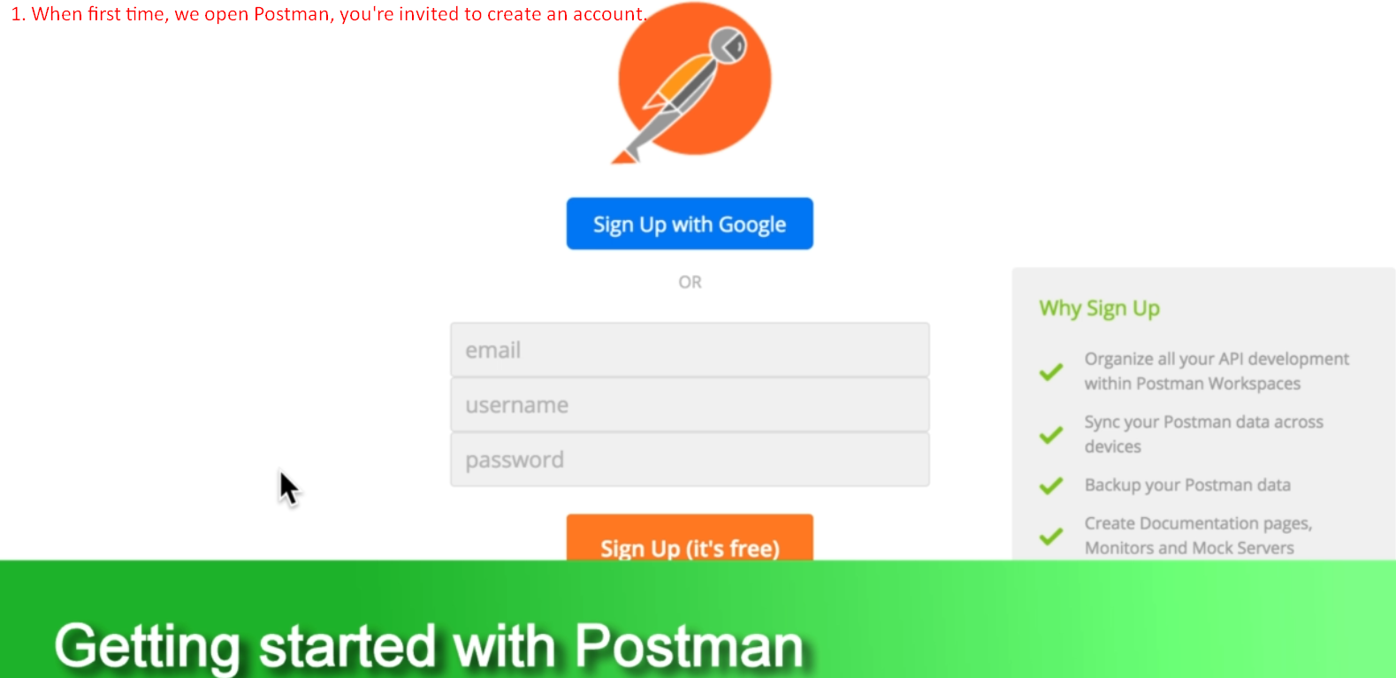
8. 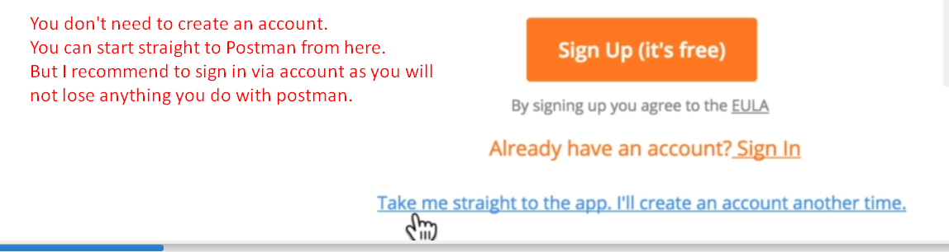
9. 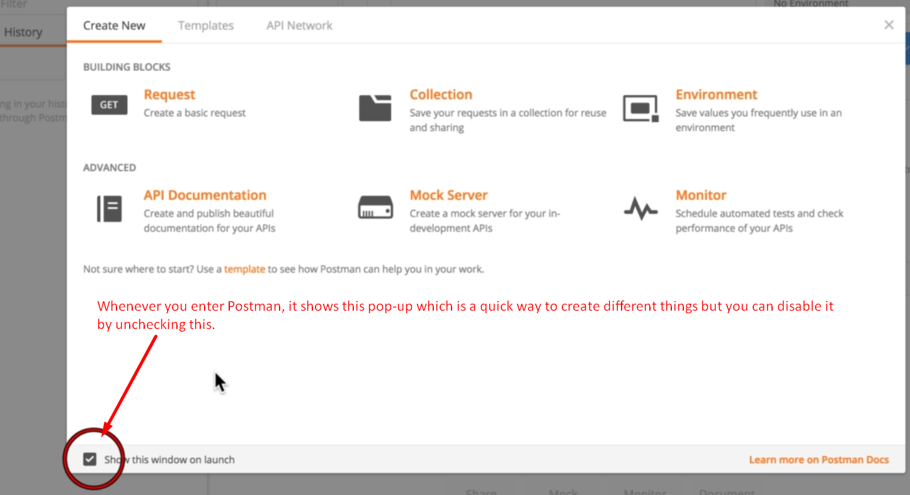
10. The UI of Postman is divided into multiple sections.
11. 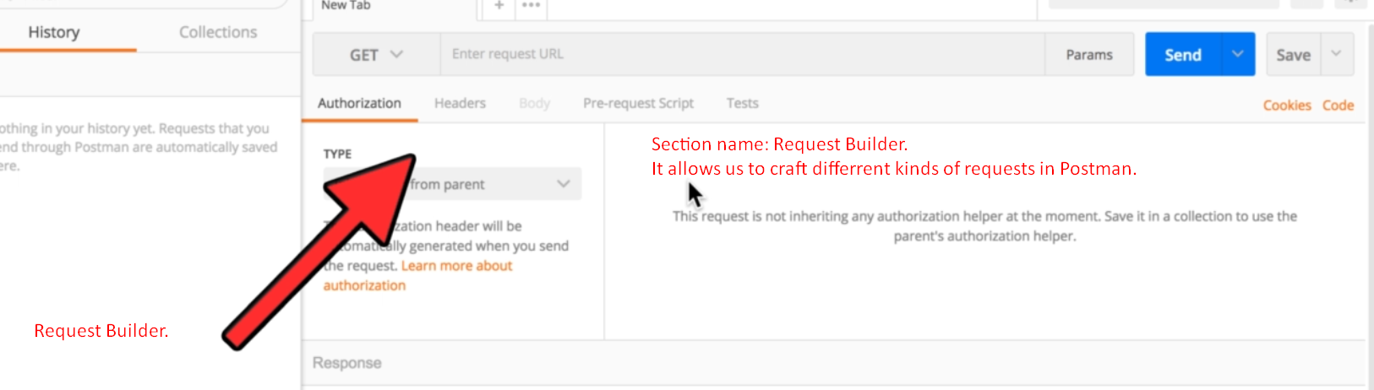
12. 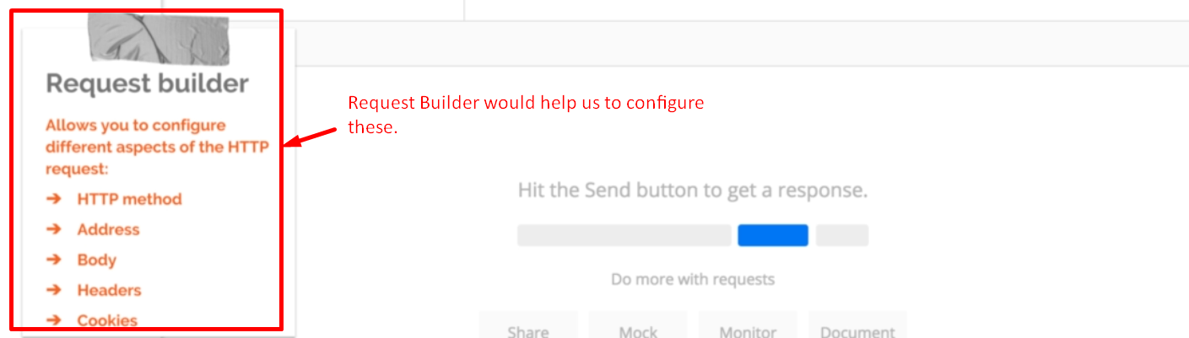

Let’s create a simple Request



1. 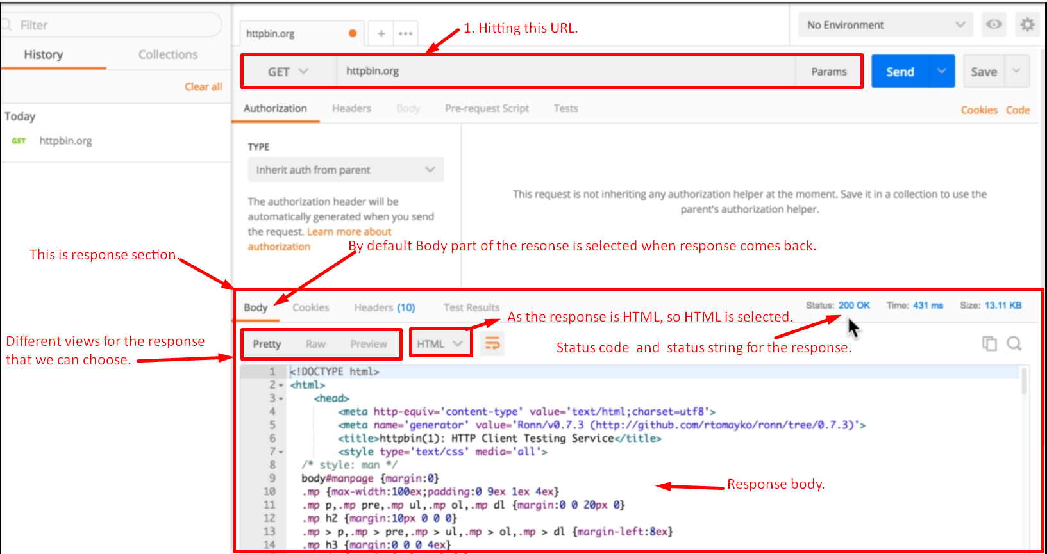
2. 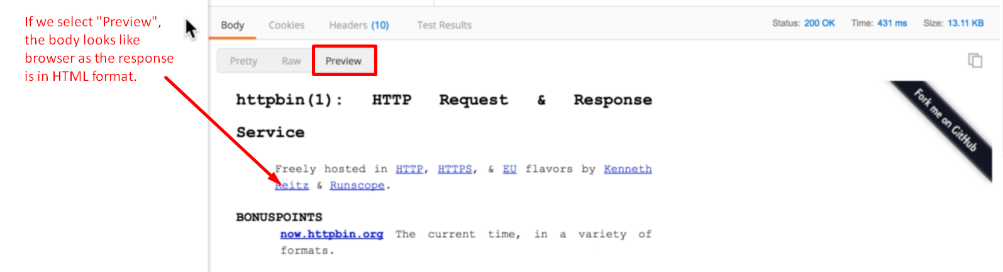
3. 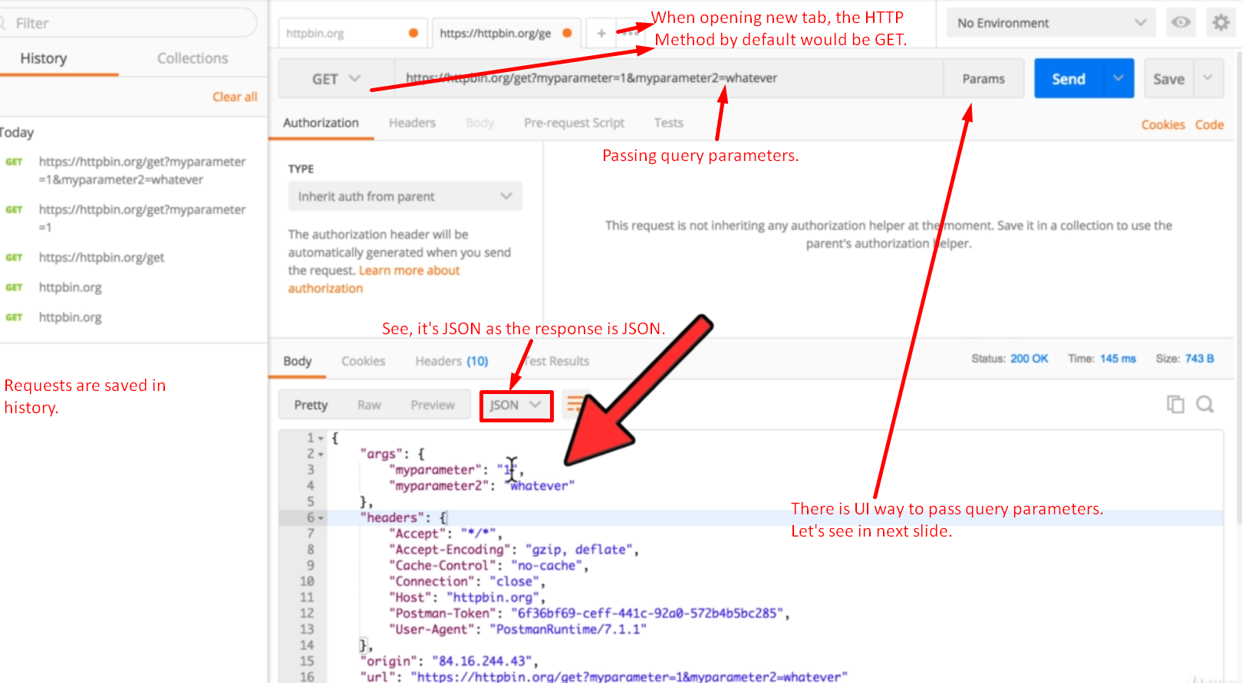
4. 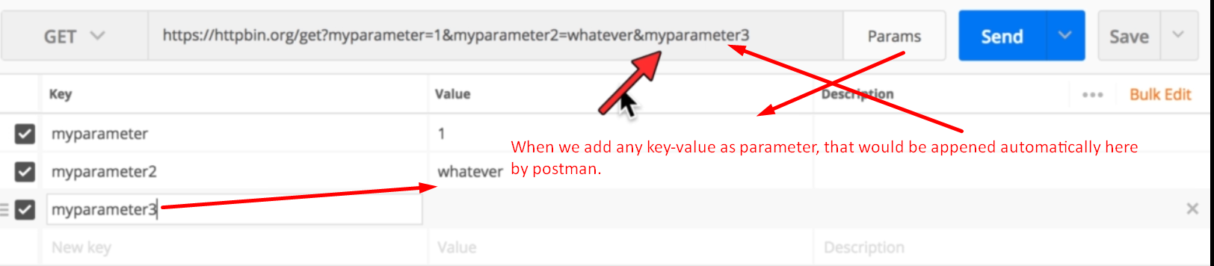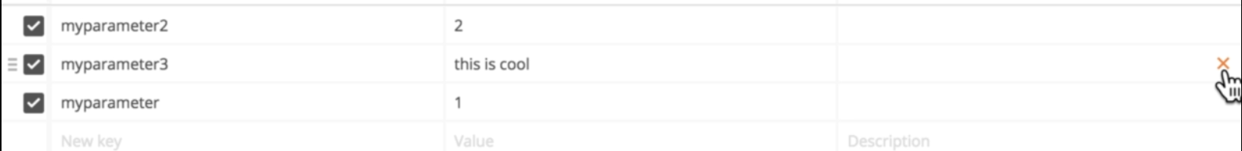
5. 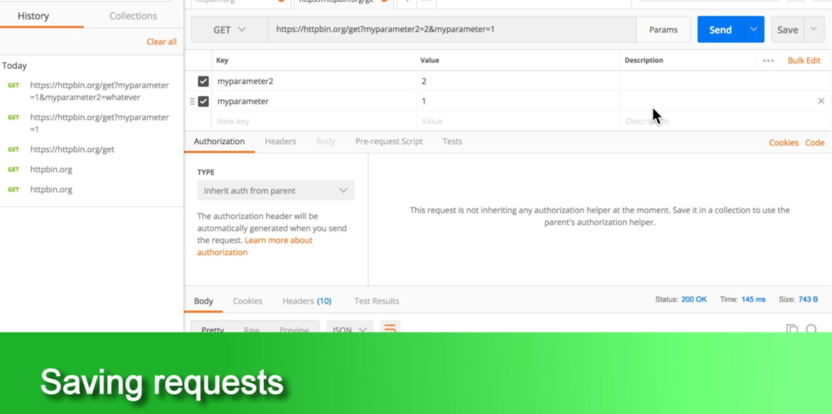
6. 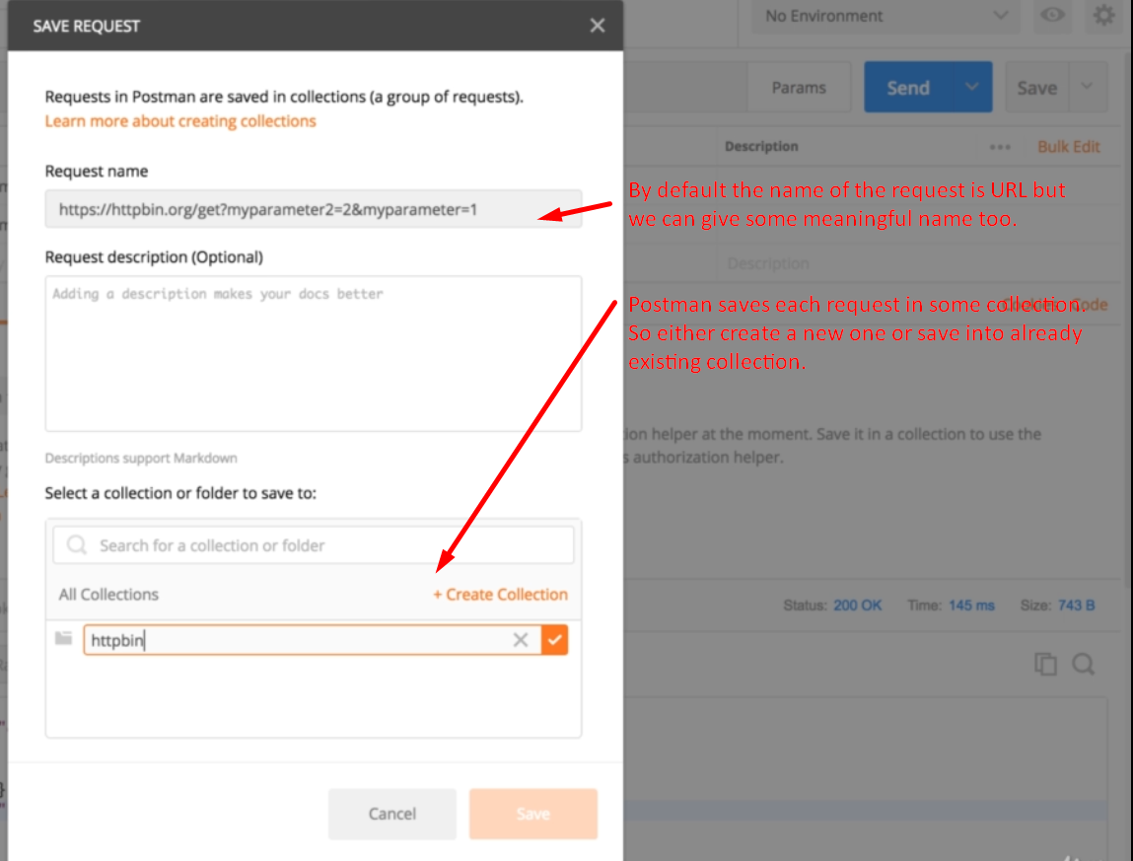
7. 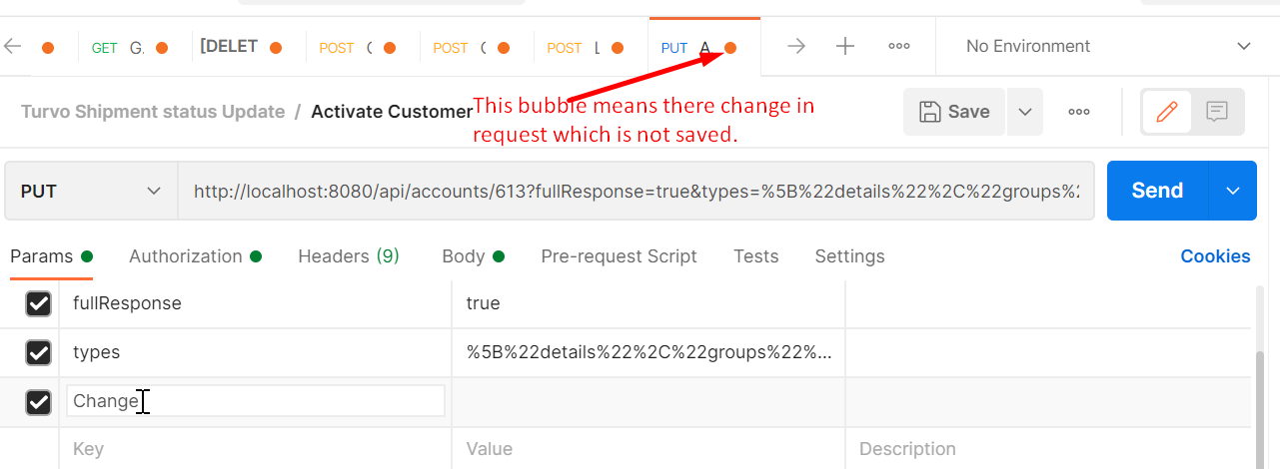
8. 
9. 